**Angular Application Deployment on Ubuntu using Nginx**

This guide explains how to deploy an Angular application on an Ubuntu server using **Node.js**, **NVM**, and **Nginx**.

**1. Update System Packages**

Update and upgrade all system packages before installation:

sudo apt update -y

sudo apt upgrade -y

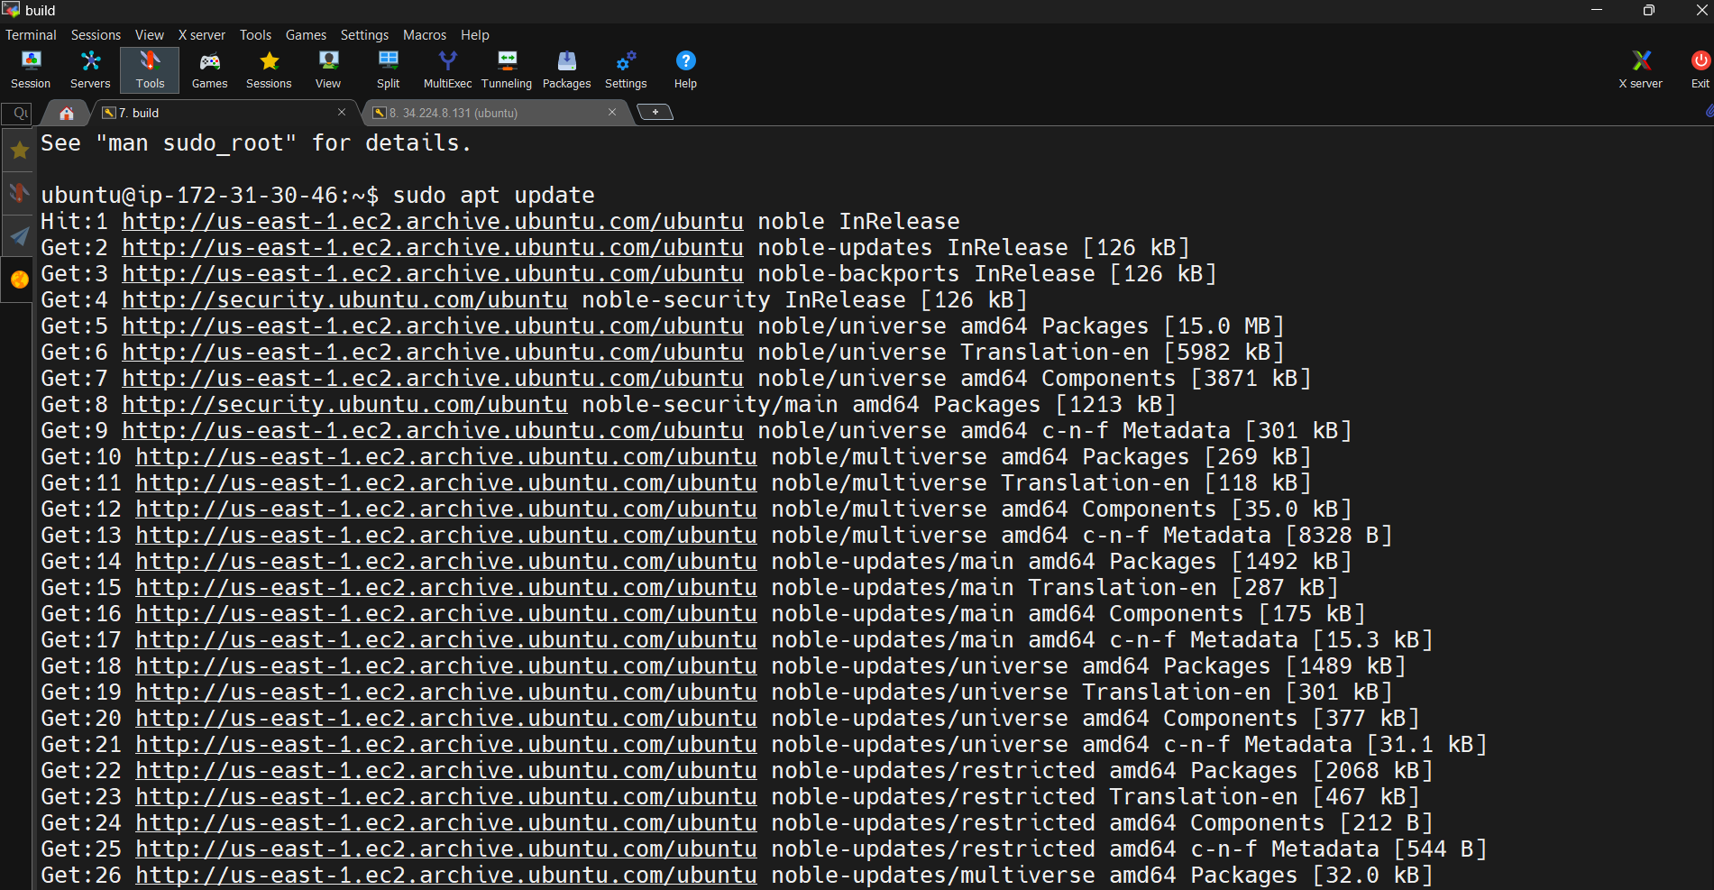

**2. Install Node.js and Angular CLI**

**Step 1: Install NVM (Node Version Manager)**

NVM allows you to easily manage multiple Node.js versions.

curl -fsSL https://raw.githubusercontent.com/nvm-sh/nvm/master/install.sh | bash

source ~/.bashrc

**Step 2: Install Node.js (LTS Version Recommended)**

nvm install 20

nvm use 20

nvm alias default 20

**Step 3: Verify Node.js and npm Installation**

node -v

npm -v

You should see versions like:

v20.x.x

10.x.x

**Step 4: Install Angular CLI Globally**

npm install -g @angular/cli

Verify installation:

ng version

**3. Clone and Build Angular Application**

**Step 1: Clone Your Project from GitHub**

git clone https://github.com/Ai-TechNov/AngularCalculator.git

cd AngularCalculator/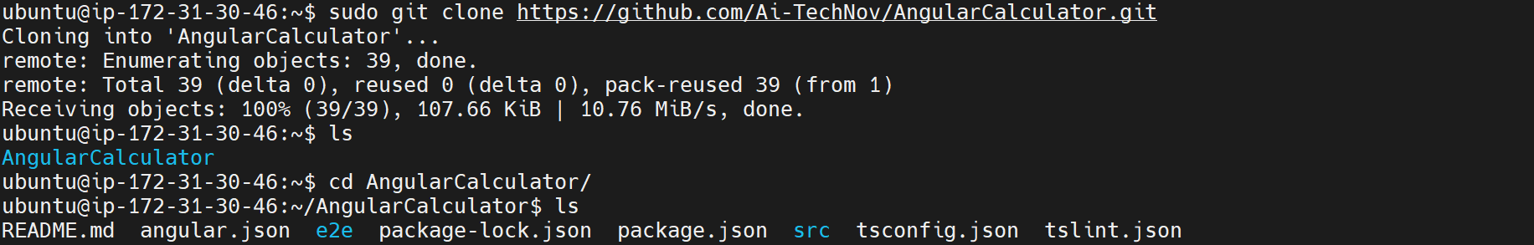

**Step 2: Install Dependencies**

npm install

If you face dependency errors, run:

npm install --legacy-peer-deps

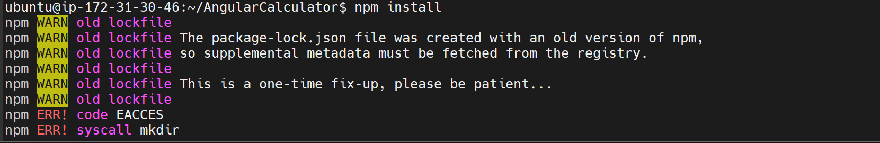

**Step 3: Fix OpenSSL Issue (Optional)**

If you encounter OpenSSL-related build errors, run:

export NODE_OPTIONS=--openssl-legacy-provider

**Step 4: Build Angular Application**

ng build --prod

The build output will be generated in the dist/ folder.

**4. Install and Configure Nginx**

**Step 1: Install Nginx**

sudo apt install nginx -y

Check Nginx status:

sudo systemctl status nginx

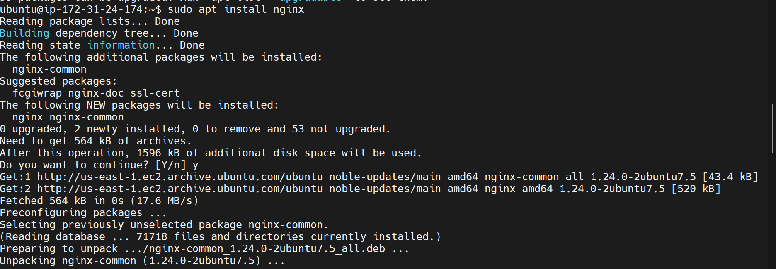

**Step 2: Remove Default Web Content**

sudo rm -rf /var/www/html/*

**Step 3: Copy Angular Build to Nginx Directory**

Check your actual build folder inside dist/ — for example:

sudo cp -r dist/AngularCalculator/* /var/www/html/

🔸 Replace AngularCalculator with your actual build folder name if different.

**Step 4: Set Correct Permissions**

sudo chown -R www-data:www-data /var/www/html

sudo chmod -R 755 /var/www/html



**Step 5: Restart Nginx**

sudo systemctl restart nginx

sudo systemctl enable nginx

**5. Access the Angular Application**

Open your browser and go to:

http://<your-server-public-ip>/

Example:

<http://34.224.8.131/>

If everything was successful, you’ll see your Angular app running in the browser

